Dress measuring guide for women:
To ensure accurate measurements we suggest having a professional seamstress measure you. If you do not get a professional seamstress to take your measurements you should follow this guide to ensure proper fit.
We will make your garment according to the measurements you provide. Any alterations, fittings, changes or adjustments, if necessary, can be easily be done by any of your local seamstresses or tailors. We are not responsible for a client’s fluctuation in weight.
Note: Please provide your actual measurements in inches.

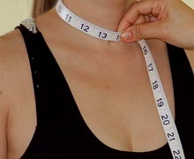
Neck |  | Neck Opening
Measure around the neck |  | Measure from center front neck to your desired neckline
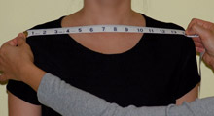 |  | 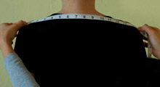
Shoulder Front |  | Shoulder Back
Measure from shoulder tip to shoulder tip |  | Measure from one edge of the shoulder to the other, across back (taken at back)
Chest Front |  | Chest Back
Measure from one mid-armhole  to the other |  | Across back, measure from one  mid-armhole to the other
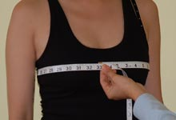 |  | 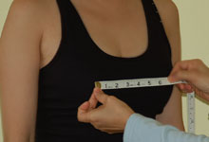
Bust |  | Bust Distance
Measure around the fullest part of your bust and straight across your back, keeping the tape a little loose for comfort. Kindly wear a bra when you take this measurement. Be aware that wearing no bra versus a strapless or regular bra can make quite a difference in measurements |  | Measure from bust point to bust point
 |  | 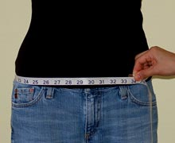
Waist |  | Hip 1
Measure around your natural waist |  | Measure around your hips, 3” below your waist
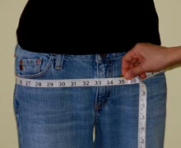 |  | 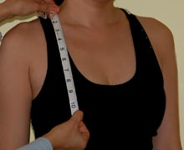
Hip 2 |  | Shoulder to Bust
Measure around 7" below your waist or around the fullest or widest point of hip |  | Measure from shoulder to bust point
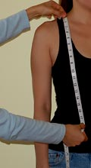
Shoulder to Waist (front) |  | Shoulder to Waist (back)
Measure from shoulder at neck to waist |  | Measure from shoulder at neck to waist
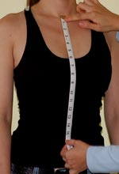 |  | 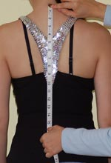
Center (front) |  | Center (back)
Measure center front neck to waist |  | Measure from center back neck to waist
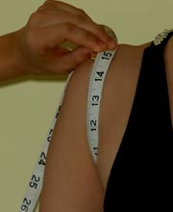 |  | 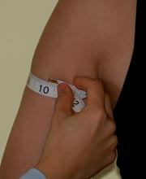
Armhole |  | Bicep
Measure from shoulder tip to bottom of armhole to shoulder |  | Measure around your arm, under the armpit
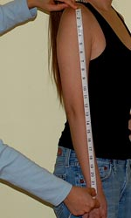 |  | 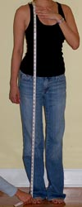
Sleeve Length |  | Dress Length
Please measure from the tip of your shoulder to desired end point of sleeves |  | Please measure midpoint of your shoulder, over the fullest part of your bust, to hem or desired end of dress (without shoes). For a full-length dress, measure from top of your shoulder to the floor without shoes
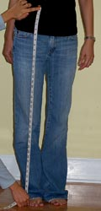
Skirt Length
Measure from waist to hem or desired length

